Chapter 13, Solution 32.

We first find Z_{in} for the second stage using the concept of reflected impedance.

R
L_{b}
L_{B}
Z_{in}’

Z_{in}’ = jωL_{b} + ω²M_{b}²/(R + jωL_{b}) = (jωL_{b}R - ω²L_{b}² + ω²M_{b}²)/(R + jωL_{b}) (1)

For the first stage, we have the circuit below.

L_{a}
L_{A}
Z_{in}
Z_{in}’

Z_{in} = jωL_{a} + ω²M_{a}²/(jωL_{a} + Z_{in})

= (–ω²L_{a}² + ω²M_{a}² + jωL_{a}Z_{in})/( jωL_{a} + Z_{in}) (2)

Substituting (1) into (2) gives,

= 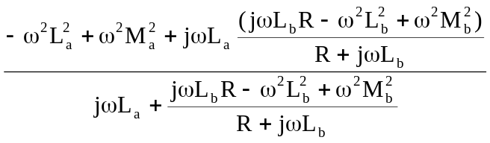

–Rω²L_{a}² + ω²M_{a}²R – jω³L_{b}L_{a} + jω³L_{b}M_{a}² + jωL_{a}(jωL_{b}R – ω²L_{b}² + ω²M_{b}²)
=
jωRLa –ω²L_{a}L_{b} + jωL_{b}R – ω²L_{a}² + ω²M_{b}²

ω²R(L_{a}² + L_{a}L_{b} – M_{a}²) + jω³(L_{a}²L_{b} + L_{a}L_{b}² – L_{a}M_{b}² – L_{b}M_{a}²)
Z_{in} =
ω²(L_{a}L_{b} +L_{b}² – M_{b}²) – jωR(L_{a} +L_{b})

